School Council Newsletter
Issue 1, Spring

A big, big thank you to all the children, parents and staff!
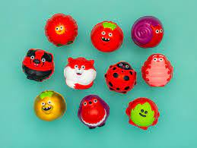
With your support on Red Nose Day, Grangetown Primary School raised £470.00 for Comic Relief. This is the most money we have ever raised for Comic Relief. Thank you for all your support and generosity!

Spring Chicks
School Council is selling Spring Chicks. The cost of each chick is £1. Inside the spring chicks there will be a chocolate creme egg, The spring chicks were kindly knitted by Mrs. Whittle’s mother-in-law.



All the money raised will be going to Tenovus, Macmillan and Velindre cancer charities.

ECO ALERT
Eco-Committee would like to remind everyone to walk, scoot or ride your bike to school everyday to try and win prizes for our school in the Sustrans Big Walk and Wheel Competition.

World Book Day
On Friday 8th April we will be celebrating World book day - make sure you wear your pj’s to school!

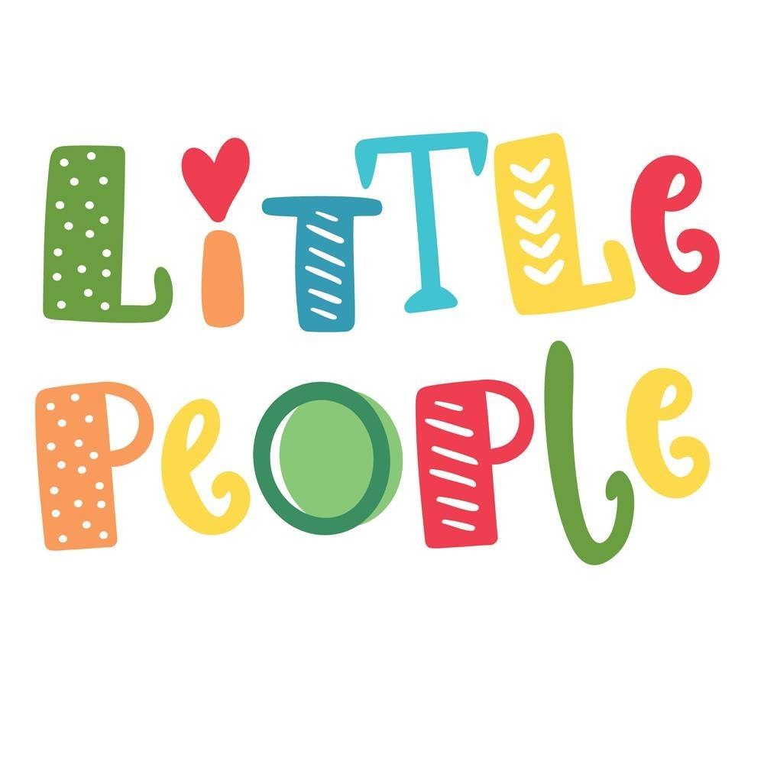
Final thank you
Thank you to the Little People Store, a children’s shop in Rhiwbina who have kindly offered to donate any remaining World Book Day books to our school. We are very grateful.

Written by Tabid and Abdilahi, School Council

