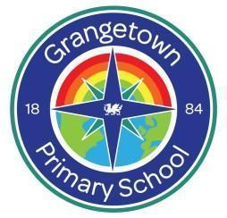
Ysgol Gynradd Grangetown Primary School Governors’ Annual Report for 2023—2024

Learning together for a bright future

This report refers to the autumn, spring and summer terms

September 2023 - July 2024

Our school is an English medium primary school welcoming 4-11 year olds.

Chair of Governors Clerk to Governors
Miguela Gonzalez Nicola Manfield
c/o Grangetown Primary School c/o Grangetown Primary School
Bromsgrove Street Bromsgrove Street
Cardiff Cardiff
grangetownprm@cardiff.gov.uk

Statement from the Chair of Governors
The 2023-2024 academic year at Grangetown Primary School has been one of remarkable progress and renewed energy. The sense of recovery and resilience across our school community has been unmistakable as this year has brought a newfound confidence in both pupils and staff. Innovative teaching practices have truly taken root and flourished in our classrooms.
Our teachers have embraced new approaches with creativity and enthusiasm, delivering lessons that spark curiosity and deepen understanding. It’s been a joy to see how engaged and confident our pupils have become as they adapt to new ways of learning.
For our teachers, this year has been about finding their stride as the roll out of the new curriculum continues. With the lessons of recent years as a guide, they’ve pushed forward with fresh ideas and a renewed focus on teamwork and innovation. The result has been a vibrant, supportive environment that allows everyone, pupils and teachers alike, to thrive.
None of this would have been possible without the unwavering support of our families and the commitment of our school leadership. Together, we’ve created a community that not only adapts to change but actively embraces it, setting the stage for continued growth and success.
Thank you to everyone who has contributed to this extraordinary year. Grangetown Primary School is stronger than ever, and we look forward to building on this momentum as we nurture the bright futures of our students.

Parent Meetings

During 2023-2024, a meeting of parents and the Governing Body was not requested or held. Governing bodies. Parents can ask for up to 3 meetings in any school year with a governing body, on matters which are of concern to them.

Your Right to Request a Meeting with the Governing Body

The Schools Standards and Organisation (Wales) Act 2013 (The Act) removed the requirement for school governing bodies to hold an annual meeting with parents. Instead, new arrangements were introduced to enable parents to request up to 3 meetings in any school year with a governing body, on matters which are of concern to them.

If parents wish to use their rights under the Act to hold a meeting, 4 conditions will need to be satisfied:
1. Parents will need to raise a petition in support of holding a meeting
The parents of at least 30 registered pupils will need to sign the petition. If it is a paper petition, then a written signature must be given as well as the name and class of each child who is a registered pupil at the school. If the petition is in electronic format, the “signature” required is the typed name of the parent plus the name and class of each child who is a registered pupil at the school and the email address of each parent who “signs” the electronic petition.
2. The meeting must be called to discuss matters which affect the school
The meeting cannot be called to discuss such matters as the progress of individual pupils, or to make a complaint against a member of the school’s staff or governing body.
The petition should contain brief details of the matter(s) to be discussed, and the reasons for calling the meeting. This information should be clearly displayed at the top of the petition, with parents’ signatures appearing below.
3. A maximum of 3 meetings can be held during the school year
The law allows parents to use their rights to request up to 3 meetings with a school governing body during the school year.
4. There must be at least 25 school days left in the school year and this begins on the day after the petition is received.
The law makes it a condition that at least 25 school days are left in the school year when the petition is received so that the meeting can be held.
A “school day” means a day when the school is open to pupils; it does not include weekends, public holidays, school holidays or Inset Days.

The address for service if a petition requesting a meeting with this school’s governing body is:

Grangetown Primary School, Bromsgrove Street, Grangetown, Cardiff, CF11 7XS.
Email address: grangetownprm@cardiff.gov.uk

Further advice on how parents may go about requesting a meeting with a governing body is available on the Welsh Government’s website at:
http://wales.gov.uk/topics/educationandskills/publications/guidance/parents-meetings-statutory-guidance/?lang=en

Our Current Governing Body (dates show term of office end)

Name | Date term of office ends | Role | Appointed by
Miguela Gonzalez Chair | 30.04.25 | Local Authority Governors | Appointed by LA
Ashley Lister Vice Chair | 29.06.25 | Local Authority Governors | Appointed by LA
Sian Chase |  | Headteacher
Lucy O’Connell-Beech | 29.09.2028 | Teaching Staff Governor | Elected by teaching and non-teaching staff
Ifrah Mahamoud | 27.03.2027 | Support Staff Governor | Elected by teaching and non-teaching staff
Huda Ali | 01.03.2026 | Parent Governor | Elected by parental vote serve for a 4 year term
Saynab Faarah | 03.07.2027 | Parent Governor | Elected by parental vote serve for a 4 year term
Nick Rowe | 15.03.26 | Community Governors | Members of the local community with specialist skills which are felt to add to the expertise of the body as a whole
Jason Camilleri | 22.04.2027 | Community Governors
Ali Abdi | 09.12.24 | Community Governors
Cathryn Knight | 25.11.2025 | Community Governors
Nicola Herbert |  | Deputy Headteacher Observer
Nicola Manfield |  | Clerk to the Governing Body

Election of Parent Governors
Details of Parent Governors will be sent home when we have a vacancy. We are particularly grateful to our Parent Governors who play an important part in the Governing Body.

Gifts
The school is very fortunate to receive an annual gift of £10,000 from an ex-pupil – Betty Upton. Mrs Upton’s family provide extra-curricular experiences to enrich what the school can offer the children. This year, the money was used to help fund the uniform swap-shop, the Y6 residential and a visit to the panto. Governors extend their thanks to Mrs Upton’s son, Robert Upton, and granddaughter, Lucy Upton, for their continued generosity in their late mother and grandmother’s name.

Sporting Activities
PE continued in all year groups. Staff ran after school sporting clubs for football. Mr Marsden and Ms Zahoor also ran a local schools’ football tournament which was thoroughly enjoyed. Y6 and Y4 attended swimming lessons at the Cardiff International Pool. Y4, 5 and 6 attended cricket events at Sophia Gardens, and Years 3-6 attended an inter-schools sports event at Marl Park.

Community Links
The school began to reinstate a range of family and community work. Mrs Lalik, our Family Liaison Officer organised classes for parents which included: Classroom Assistant, Sewing classes, Families Learning Together and IT classes. Parents were also able to access First Aid training and Food Hygiene accredited courses.
The school supported our community through the establishment of a School Uniform Swap Shop. This was generously supported by Robert Upton, and his daughter Lucy, who provided a stock of brand new uniform, in various ages, to seed the Swap Shop.
School secured a £400 voucher from Hugg which allowed us to buy food from a local supermarket to distribute amongst our families.
Staff were generous in donating their time to running after school clubs. As well as the sporting clubs, teachers also offered: Gardening Club, Choir and Coding club.
Pupil Voice groups were reinstated and these helped to shape the school’s work. For example, School Council raised money for charities.
The school also has good links with Grangetown Pavilion. This year we attended the Grangetown Festival - dressed as bees! Mrs O’Brien also ran a stall with all proceeds going to the Oasis charity. The local PCSO police officers are welcome visitors to the school.
Parent meetings to share the school’s work were held in the summer. These covered: ALN, the curriculum and Diversity, Equality and Inclusion. We also offered parents a chance to come in and see the RSE lesson plans and resources school uses to teach this part of the curriculum.
We really enjoyed celebrating the community’s religious festivals. We held our very first Iftar and this was so enjoyed by all who attended. We also held an Eid assembly which was put together by the children - with a little help from staff of course! We welcomed leaders from the Temple, the Church and Humanists who have given assemblies sharing their beliefs with the children.
A Newsletter is published monthly, on the website, to keep parents up to date with the work the school is doing, and the experiences their children are having.

Statutory Documentation and Policy Timetable
Policies are reviewed regularly by the Governing Body. Key Policies can be looked at on the school website. If you would like to access any policies, or talk about them, please contact the school administrator.

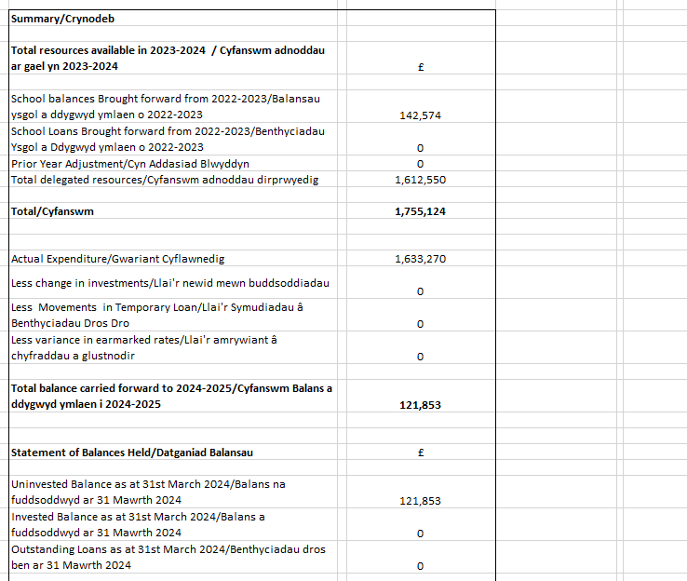
Financial Statement

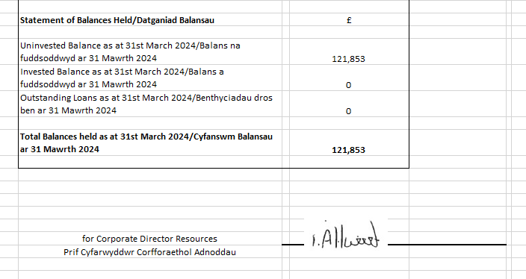

School Term and Holiday Dates
Term | Term starts | Half-Term starts | Half-Term ends | Term ends
Autumn 2024 | 02/09/2024 | 28/10/2024 | 01/11/2024 | 20/12/2024
Spring 2025 | 06/01/2025 | 24/02/2025 | 28/02/2025 | 11/04/2025
Summer 2025 | 28/04/2025 | 26/05/2025 | 30/05/2025 | 21/07/2025

Our School Timetable

 | Start | Lunch | Finish
Reception | 8.55am | 11.45-12.45pm | 3pm
Year 1 | 8.55am | 12-1pm | 3pm
Year 2 | 8.55am | 12-1pm | 3pm
Year 3 | 8.55am | 12-12.45pm | 3.05pm
Year 4 | 8.55am | 12-12.45pm | 3.05pm
Year 5 | 8.55am | 12-12.45pm | 3.05pm
Year 6 | 8.55am | 12-12.45pm | 3.05pm

School Prospectus
Copies are available from the school office. The prospectus is updated annually.

Curriculum – organisation and teaching methods
The school follows the Curriculum for Wales, and this was implemented across Wales from September 2022. The school has been working on understanding the demands of the new curriculum culminating in the adoption of an Understanding by Design approach. The school has a fully explained summary of the curriculum on its website which can be accessed here: Grangetown Primary - Successful Futures - A Curriculum for Wales - Cwricwlwm i Gymru

Additional Learning Needs (ALN)

Alyssa White is the Additional Learning Needs Co-ordinator and Dr. Cathryn Knight is the link governor. Dr. Knight’s work includes researching ALN and inclusion in Wales.

The school remains firmly committed to the principles of inclusive education, embodying a philosophy where every student is embraced, valued, and encouraged to reach their full potential. We aim to actively foster an environment that prioritises diverse learning styles, cultivates mutual respect, and provides personalised support to cater to individual needs. Through these inclusive practices, we aim to eliminate barriers to learning, celebrate diversity, and establish a sense of belonging that empowers each child to excel academically, socially, and emotionally.

The school maintains a careful approach to identifying individual children with ALN. A Class Action list is kept by Mrs. White and she oversees the additional targeted and individual support some children may need. The school identifies the first step in addressing learning support needs through Class Action. This is met through high quality teaching and differentiation by the class teacher.

If little or no progress is made after two terms, a child is moved to the next stage: Class Action Plus. At this stage a child may receive additional support, individually and in small groups. A One Page Profile, with SMART targets, is written by the class teacher and overseen by Mrs. White. Wherever possible, these are co-constructed with the child and parents. At this stage, depending on need, a Specialist Teacher from the Local Authority might become involved to help set up a specific learning or behaviour programme.

If there continues to be less progress than expected, the school may write an Individual Development Plan (IDP). Parents are also invited to share information about their child’s development and level of difficulty. The information is gathered through a Person Centred Meeting where professionals, school, parents and - if appropriate - the child meet to discuss the best ways to meet the child’s needs. The aim of these meetings is to place the needs of the child as central to the decision making.
For more information on ALNET see information on the school’s the website here: Grangetown Primary - ALN - Additional Learning Needs - Anghenion Dysgu Ychwanegol

Support programmes available to pupils this year included;
Language Link – receptive language development
Letters and Sounds
Rapid Readers
Rainbow Readers
Maths Factor
Place 2 Be

Parents of a pupil with ALN can seek advice from SNAP Cymru (Special Needs Advice for Parents, Wales www.snapcymru.org). The organisation supports parents and pupils in securing the right provision for as long as is necessary.

Welsh Language


Welsh is taught throughout the school both as a stand alone lesson and through daily 10-minute practice sessions. Welsh is used incidentally throughout the day via greetings and basic instructions. We are proud to hold the bronze Siarter Iaith Award and we are currently working towards the silver award.

Toilet Facilities
There are toilet facilities for the Reception children, next to their classes. Year 1 and 2 have toilet facilities near their classes. KS2 has toilets upstairs and downstairs. These are cleaned by contract cleaners once daily after the children have left school. All children have access to cubicles with a paper dispenser. Soap is replenished as necessary. Paper towels and hand dryers are in all toilets.

Healthy Eating
Breakfast Club runs in the school and offers toast, fruit juice and cereal. The school kitchen follows Cardiff Catering menu which is aligned with healthy eating goals. The school implemented Welsh Government’s free school meal programme resulting in all children being eligible for free school meals. All children can bring a healthy snack to school, and this must be fruit and water. Milk is provided for all children from Reception to Year 2. We continue to aim to educate children about the importance of healthy eating by covering it through the curriculum.

School Development Plan
School Improvement Priority Targets: 2023-2024
SIP | School Improvement Priorities 2023-2024 | Expected Outcomes
1 | Curriculum Design | Embedding a progressive approach  - Curriculum is underpinned by WG guidance.  - Consolidate UbD process.  - Cluster progression maps are used to structure a clear, coherent and progressive learning journey across all UoLs.  - UoLs include authentic exploration of LNF and DCF tasks.  - AoLE action plans address LNF and DCF.  Monitoring and Assessment  - Learning progress is evident through the school.  - Cross-curricular skills are explored in every UoL  - Assessment practice is in line with CfW mandatory demands.  Stakeholders  - Governors participate in school curriculum work.  - Parental feedback informs the curriculum.  - Pupil Voice is considered in learning.
2 | Maths and numeracy | - Improved knowledge of 5 proficiencies is evident in planning and this impacts positively on children’s work.  - Rich and authentic Numeracy rich tasks are evident across the curriculum..  - Sequential and coherent CfW maths overviews and unit plans are created, developed and implemented.  - Data analysis is used to ensure children are making progress within Maths.
3 | Learning and Teaching | Embedding a progressive approach  Assessment  - Assessment practice is in line with CfW mandatory demands.  - APP meetings are completed termly  Metacognition  - Metacognition is understood within the remits of CfW principles of progression  - Metacognition supports pupils journey to become effective learners  - Integral skills are introduced into units of learning  Pedagogy  - Continue to strengthen the ‘Why?’ and ‘How’ about pedagogy choices -Implement fully school’s L and T policy  - Ensure that the challenge and pace of learning are effective in meeting all pupils’ needs - links to L and T policy  Stakeholders  - All teachers to collaborate and reflect on their developmental needs to iIdentify and develop high quality teaching using Great Teaching Toolkit, EEF Toolkit, Rosenshine and Understanding by Design  - Pupil voice is sought, evaluated,reviewed and acted (AoLE L2L)  - Governors are active participants in the delivery the L and T Action Plan  - Parent views are sough

School Improvement Priority Targets: 2024-2025
SIP | School Improvement Priorities 2024-2025 | Expected Outcomes
1 | Anti-Racism | Professional Learning needs  - School community knowledge of anti-racism and DEI is improved and applied  - NAS completed accurately.  Progress and Monitoring  - CATE documents support NEWBEs language acquisition.  - DEI is clear in UoL work and the school environment.  - School knows, and deals with, any incidents of race/ homophobia and equality issues.  Curriculum  - Curriculum and school environment reflect society.  Collaborative work  - DARPL DAN work completed.  Stakeholder involvement  - Parents are involved with school’s DEI and Anti-Racism work.  - High profile celebratory assemblies involve parents and children.  - Pupil/staff committees contribute to school’s work.  School of Sanctuary  - To renew SoS status.
2 | Language, Literacy and Communication | PL, staff training and collaboration  - Reading and spelling approaches are understood and consistently implemented across the school.  - Work completed with FHS on International language in Y6.  - In-house and external collaboration impacts on progress and staff knowledge.  Progress and monitoring  - Children make at least expected progress in reading and spelling (NGRT/GL/WG).  - Oracy opportunities are embedded.  Knowledge, Skills and experiences development  - Voice 21 leads school’s oracy practice.  - Rich variety of reading experiences across the school.  - Balanced range of writing genres across the school.  Stakeholder involvement  - Parents: involved in children’s LLC engagement.  - Wider community: LLC links established.  - Governors: actively support the school’s work  Pupil Voice  - Pupils are actively engaged in LLC work.
3 | Learning and teaching | PL, staff training and collaboration  - SLO survey informs school work and there are clear links emerging between SLO next steps and teaching standards.  - L and T policy reviewed and then implemented by staff.  - Teachers identify their key areas for development - linked to reading - through reflective practice.  - Collaborative work improves the effective pedagogy of reading  - Professional Learning supports SIP.  - Emerging use of metacognitive strategies in reading.  Assessment, Progress and monitoring  - All teachers use summative and formative assessment data to drive pupil progress.  - Challenge and pace of learning are effective in meeting all pupils’ needs.  Stakeholders  - Governors have first hand experience of the learning and teaching  - Children share their views on learning and teaching - what they like and don’t like eg. engagement  - Parents' feedback is considered.

