

Learning together for a bright future

GRANGETOWN PRIMARY SCHOOL

WHOLE SCHOOL POSITIVE BEHAVIOUR MANAGEMENT POLICY

At Grangetown Primary School we aim to provide a happy, caring environment in which all children can feel confident and able to learn. We seek to foster an environment of mutual respect and support between all staff, pupils, parents and carers and the wider community.

Our school is committed to eliminating any unlawful discrimination on grounds of Race, Gender, Transgender, Religion or Belief, Disability or Sexual Orientation, Pregnancy or Maternity Marriage or Civil Partnership by creating an environment where every individual, regardless of ability or background, is able to participate and is valued fully as a member of the school community. Being opposed to all forms of discrimination and prejudice we promote a positive attitude towards differences and expect respect for people of all backgrounds”

Date of Ratification: 4th March 2024

Review Date: Spring 2026

The following guidelines have been shared with staff during INSET sessions and research assemblies allowing time for staff to reflect on the policy.

THE WHOLE SCHOOL ATMOSPHERE

We aim to create a caring and happy atmosphere where diversity is celebrated and all who spend time here can feel secure, confident and are ready to learn.

Our school fosters a sense of community where the way the staff, the children and visitors treat each other, reflects the way in which we want the children to behave. We treat everyone positively, with appreciation, kindness and respect. All are praised publicly and reprimanded in private.

This atmosphere forms part of the hidden curriculum and will have a great effect on the success of the school in achieving its aims.

The United Nations Convention on the Rights of the Child
School and its Governing Body must uphold the principles of the United Nations Convention on the Rights of the Child. Rights of the Child Article 12 - right to be listened to. The School Council and Rights Respecting Committee are involved in discussions about positive behaviour management in school attendance. See Appendix 5

PRINCIPLES

The positive behaviour management policy is fair, consistent and known by all staff and children. It forms part of our Learning and Teaching Policy as it is the base of our 5 pedagogical pillars - Classroom Ethos and Classroom Management. See Learning and Teaching Policy

Aims
- To promote positive behaviour.
- To provide a happy, secure environment.
- To build self-esteem and mutual respect.
- To give children responsibility and ownership of their own behaviour
- To allow all children to learn

Whole School Rules
- We respect everyone and everything
- We listen to the person who is meant to be speaking
- We follow instructions first time
- We move sensibly, safely and quietly
- We keep hands, feet, objects and unkind words to ourselves

These 5 rules are for the whole school. They are on display throughout the school so that everyone is aware of them. They are referred to regularly and all staff, pupils and volunteers follow them. They are printed in our school prospectus for the information of parents, governors and any other interested parties. These rules form part of the classroom ethos.

GUIDELINES FOR POSITIVE BEHAVIOUR MANAGEMENT
Good class management is fundamental to fostering positive behaviour and to pre-empting many of those behaviours which give cause for concern.

Working with Children
- Establish a friendly, supportive, positive relationship with pupils
- Make sure that pupils are engaged in purposeful, stimulating activities.
- Create a well-organised, stimulating classroom and school environment.
- Place the emphasis on appreciation, kindness and respect which link to our values and use the Positive Behaviour Management - Grangetown Primary School Approach - See Appendix 1
- Allow children to recognise and value their emotions - linking to the Zones of Regulation (See Health and Wellbeing Policy)
- Attempt to prevent the use of sanctions by early identification of problems and using low key strategies initially such as, diverting or modifying pupils’ behaviour or having a quiet word or reminder - see Positive Behaviour Management Strategies - Appendix 2
- Be clear, firm and polite about the behaviour boundaries without being frightening or shouting.
- Be clear about the range of strategies and sanctions that may be used.
- Display and refer frequently to the school rules. Positive Behaviour Management Strategies are not on display, but are available for a visiting teacher to refer to.
- Establish clear routines for movement around and to and from the class
- Ensure that resources are clearly labelled and accessible.
- Use the school’s assertive discipline procedures as outlined in this policy for monitoring, reporting, and supporting each other in addressing the individual pupil’s needs and those of the whole school.

Working with Parents

- Promoting good behaviour is seen as a partnership between school and home. Parents are regularly informed of good behaviour.
- Parents are made aware through the school prospectus of standards of behaviour that we expect in school.
- Any child who persistently misbehaves knows that his/her parents will be informed and we would expect their co-operation in dealing with such problems.
- We hope that parents who are experiencing difficulties will feel able to communicate these to the school. If we know of difficulties/problems at home it helps us to deal more sympathetically with changes of behaviour in school.

Working with Others- Shared Responsibility.
For our behaviour policy to work effectively and consistently all teaching and non-teaching staff, parents and governors need to be involved. It is intended that this policy applies throughout the school and at all times.

LUNCHTIMES
Standards of good behaviour are expected to continue throughout the lunch hour. Problems during lunchtime can affect the atmosphere in the classroom. The LSAs and midday supervisors are trained and encouraged to use positive behaviour management techniques and follow the school policy.

- GOVERNORS
The Governing Body has the responsibility of setting down these general guidelines on standards of discipline and behaviour and of reviewing their effectiveness. The Governors support the headteacher in carrying out these guidelines.

The Headteacher has the day to day authority to implement the school behaviour and discipline policy, but Governors may give advice to the headteacher about particular disciplinary issues (eg fixed term and permanent exclusions). The Headteacher must take this into account when making decisions about matters of behaviour.

There will be a named Governor responsible for Health and Wellbeing who will work with the school in the development of strategies for promoting positive behaviour management. The named governor for ALN will also have a role to play.

INCENTIVES and REWARDS
In our school, we recognise and show appreciation, kindness & respect towards all and are aware that children respond in different ways. All staff are fully aware of the Positive Behaviour Management - Grangetown Primary School Approach, and there are a variety of ways to appreciate and value our children through appropriate incentives. Many are simple but effective – praise for example. See Grangetown Primary School Approach - See Appendix 1 and 3

Celebration Assemblies:
One child from each class will be chosen to receive praise and a certificate in the Celebration Assembly. The celebration assemblies are based on the school’s values of respectful, healthy, kind, fair and hardworking linking to the themes in the Jigsaw RSE scheme. The celebration is also linked to a learning champion, where the skills and values linked to learning are celebrated. The focus of the assemblies alternate fortnightly.

Attendance Assemblies
- Best attending class, for the week, is announced and celebrated in an assembly.
- Two best overall classes for attendance is awarded termly - Reception to Year 2 and Year 3 to Year 6.
- 100% individual attendance is awarded termly and annually

Positive Behaviour Management Strategies - See Appendix 2
Some low-level disruptions may be better ignored, but this is a fine balance in the judgement of the member of the adult dealing with the child. It is essential that children know why they are being spoken to and that the Positive Behaviour Management Strategies are applied consistently and fairly. It is also important to:
- Avoid sanctioning the whole group because of individual behaviour
- Avoid humiliation/ sarcasm – eg talk to child away from the group
- Have sanctions / consequences appropriately matched to the unacceptable behaviour
- Always offer the child an opportunity to reflect and make amends for their behaviour through the use of a think sheet See Appendix 3 for Think Sheets
- It is important for adults to have follow up conversations with the child/children using a restorative practice approach. See Appendix 2 for questions and supportive script.

SCHOOL ORGANISATION
We aim at all times to create an attractive, safe and orderly environment. Everyone is encouraged to take responsibility for maintaining a school to be proud of. Every class has a line order for the children to line up and move around the school safely, sensibly and quietly. The line order is also used outside when the children line up at the end of playtime and lunchtime. The class line order is displayed in the classroom.

Children are actively involved in decision making through creating their learning charter. Older children are encouraged to act as role models and are given opportunities to be responsible for younger pupils.

Staff
All staff are fully aware of the Positive Behaviour Management - Grangetown Primary School Approach - See Appendix 1 and the Positive Behaviour Policy Strategies - See Appendix 2.

Everyone is expected to play an active and consistent part in promoting expected and good behaviour. Where necessary, teachers teach and reteach expected behaviour. At Grangetown Primary School, we insist on it, to expect it!

All adults in school who work with and come into contact with the children will treat every child fairly and encourage them to achieve the expected levels of behaviour. All adults will speak positively, with appreciation, kindness and respect towards all children where they will be praised publicly and reprimanded in privately.

Class teachers and LSAs can offer rewards and implement the positive behaviour management strategies to promote expected levels of behaviour. However, class teachers are responsible for overseeing any actions or outcomes resulting from rewards/strategies being given.

Class teachers will implement and review aspects of IDPs with a behaviour focus for those children in their class who have them. It is the responsibility of class teachers and LSAs to read and follow any ALN documentation linking to behaviour eg. risk assessments, PSP plans etc and seek advice from the ALNCo if they are unsure.

When a supply teacher is teaching the class, teachers will outline the class/children's behaviour on the supply cover sheet, and ensure that any risk assessments and personal handling plans are available for them to read.

HEADTEACHER
The Headteacher sets the standards of expected behaviour and is responsible for ensuring that the school’s behaviour policy is implemented consistently and fairly throughout the school by all staff, pupils and volunteers.

Children sent to the Headteacher

There are a number of options available to the Headteacher to deal with incidents of completely unacceptable behaviour.

- Parents will be contacted and asked to come to school to discuss their child’s behaviour with the Head/Deputy Headteacher. The ALNCO and class teacher may also be present.
- A plan will be discussed. This could involve such measures as placing the child on class report, setting up a behaviour contract, implementing targets, putting a Risk Assessment into place and/or referring to the Emotional Health and Wellbeing team for further advice and support.
- If the unacceptable behaviour continues after these measures have been taken, then parents will be informed that their child faces exclusion from school.
- Exclusions from school for a fixed or permanent period is an action which will be considered when all else fails, or for serious single incidents. The Chair of Governors will be consulted wherever possible. Lunchtime exclusions will be considered if appropriate. Before permanent exclusion is considered, the school should set up a Pastoral Support Programme as detailed in the National Assembly circular 3/99 “Pupil Support and Social Inclusion”.

RECORDING/LOGGING INCIDENTS
Any serious incidents will be recorded on My Concern. By doing this it will be possible to monitor what is happening – who, when and where. Any pattern or repetition will then be seen and appropriate measures can be taken.

- ALN
Occasionally our framework may fail to address a child’s needs. Consultation and discussions will take place between the child, his/her parents, his/her class teacher, ALNCO and the Headteacher to set up an individual behaviour programme which clearly identifies long and short term aims for behaviour improvement.

Behaviour Contract
When a child is given a behaviour contract this will be discussed with the child, class teacher and ALNCO. A small number of targets will be agreed which the pupil will be asked to achieve over a given period of time. These should be worded in as positive a way as possible and should be achievable. The contract will be reviewed at the end of the set period and can be renewed by the staff and/or the child if necessary. This contract may take the form of a One Page Profile with social and emotional behavioural targets.

Liaison with External Agencies
When a child is experiencing behavioural difficulties, if it is necessary, the school works in partnership with outside agencies for the benefit of the child. The school will always keep parents fully informed.

- RACIAL ABUSE, SEXUAL HARASSMENT AND BULLYING
The Staff and Governors of Grangetown Primary School take the question of racial and sexual harassment and bullying very seriously. Any incident will be dealt with immediately in keeping with both our policies on Bullying and Equal Opportunities.

- PASTORAL MEETING
The school is very concerned for the welfare of all its pupils. Pastoral meetings are held regularly when amongst other things, the behaviour problems of children over whom staff have concerns are discussed and recommendations are made for action. ‘Children of Concern’ is a standing item in our weekly staff meetings.

- SCHOOL EDUCATIONAL VISITS AND EXPERIENCES
All school educational visits and experiences are linked to the Curriculum, therefore all children should take part and follow the school rules. However, if a child misbehaves to the extent that it is felt that they will be a danger to themselves or others, the class teacher, in consultation with the Headteacher or Deputy Headteacher can exclude them from any of these.

Before a child is excluded they, and their parents, must be warned that this may happen and the Headteacher or Deputy Headteacher must be involved at this point. If a child is to be excluded from a school sports team, then the team’s organiser must also be informed at each stage.

NB Misbehaviour on a school trip may result in the child being prevented from going on from the next school trip. Misbehaviour on school trips must be communicated to the head teacher and a record kept.

- TRAVEL CODE
At Grangetown Primary School we recognise and uphold the Learner Travel (Wales) Measure 2008 ‘Travel Behaviour Code Statutory Guidance; which promotes safe travel for all learners, by setting out standards of behaviour required when off school premises and not supervised by school staff. The Travel Behaviour Code is at Appendix E of our policy. Learners must comply with the Code whilst travelling to and from school. In dealing with any incidents school must refer to Section 3 of the guidance (also included at Appendix 4 of our policy)

- CONCLUSIONS
Our overall policy is to provide a caring, happy and secure environment in which children are rewarded for good behaviour. The emphasis is always on a positive approach which involves all staff and parents.

We shall review our policy every two years and make it a priority to draw it to the attention of any new staff (or students) who spend time in our school, as part of our induction procedures

Review
This policy will be reviewed biennially.

Chair of Governors: Miguela Gonzalez

Headteacher: Sian Chase

Date approved by the Full Governing Body: 4th March 2024

Date of next review Spring 2026 or sooner if amendments are advised by the LA

Appendix 1
Positive Behaviour Management - Grangetown Primary School Approach
What we do - Politely, insist on it, to expect it!
Meet and greet children at the door every session  Member/s of SLT will be on a gate in the morning greeting children and at the end of the day | - Sets tone of the session - coats off, hoods down and equipment out ready to learn etc  - Builds class ethos and monitors outside behaviour
Line up in line order…always | - Explain why - help us move safely, sensibly around the school  - Have it on display for supplies and other adults covering
Once inside the building - walking sensibly and quietly - includes corridors, in and out of assembly, hometime | - Help us move safely, and sensibly around the school  - Stop the line and look….often  - Non verbal cues - how often do we say someone's name or make more noise than the children? Eg. assembly
Teach and insist on good listening - Show me five | - Start to teach each one in Reception  - Prevents shouting out and talking over adults/children
Well established classroom routines - visual timetable, monitors, well organised classroom, seating / carpet plans | - Good classroom organisation - basis of our PP  - Learning Environment Checklist

Appreciation, Kindness and Respect - Politely, insist on it, to expect it!
- Appreciate children - all children respond differently
  - Thank you
  - Praise - well done, great….yn gymraeg!
  - Praise and catch them going over and above - remind often - explain why
  - show work to class/another class/previous teacher/SLT
  - share work as part of celebration assembly or to parents
  - stickers and notes home
  - See Catch them Being Good below

- Privileges, such as being class monitors.
- 3P board
  - Performance - standards, attainment
  - Progress
  - Productive habits of learning - hard workers
- Whole class marbles -
  - 10 marbles - Rec-Y2
  - 15 Marbles - Y3/Y4
  - 20 Marbles - Y5/6
  - Let the children decide the prize of eg. extra play, games, parachute, film - let children decide!
- Table Points - visual - do not take away!
- Trailed approach in some classes
  - Recognition board
- Celebration assemblies
  - Star of the Week/ Seren Yr Wythnos - linking to values
  - Learning Champion/ Hyrwyddwr Dysgu
  - Attendance
  - Headteacher Termly Award
  - Betty Upton Awards
- No raffle tickets - prizes- expectation to have a monetary reward
- No Dojos

But children will become emotional and will show this in different ways - Politely, insist on it, to expect it!
- Refer to the Zones of Regulation  - Children with high tariff behaviour - IDPs and/or Risk Assessments  - Challenging behaviour - have you spoken with Alyssa? Created OPP? | - Zones of Regulation links to the Health and Wellbeing Policy  - Have you read ALN documentation them for your new class?  - Have all the adults read them? Are the strategies being consistently applied?  - Base of our L and T Policy - 5PP - Research the class and children
But…children will challenge - Politely, insist on it, to expect it!
- Use the PBM Strategies Grid to support  - Do not withdraw activities eg. PE or play time or take away especially whole class  - Do not stand children outside the door - to do what? How do they feel? How would you feel? Follow the PBM Strategy Grid  - Give children space and respect - sentence stems and restorative questions to support  - Don’t tag team - if an adult/teacher is speaking to a child let them handle the situation - Caveat - SLT may get involved  - Stay in control - feel yourself become emotional - ask for more help | - Follow the PBM grid and restorative approach with children - this will be developed to link to zones of regulation Copy of 2023/24 Positive Behaviour Management Strategies.docx  - 5Rs - Relationship, Respect, Responsibility, Repair, and Reintegration  - Think sheets will be reviewed and redeveloped with children - use the current ones for now  - Create pack ready to give out this week

CATCH THEM BEING GOOD!

Think of the many opportunities to show children you’ve noticed their positive behaviour in
- Coming into the room quietly  - Being kind  - Showing enthusiasm  - Carrying out a classroom job responsibly  - Offering help without being asked  - Staying on task  - Telling the truth  - Rising to a new challenge  - Behaving courteously to visitors to the school  - Doing extra research outside school  - Taking part in school clubs and events  - Showing a positive attitude  - Making their best effort  - Taking part in activities in the wider community  - Taking part in a group activity  - Showing creativity  - Keeping busy when work is finished  - Taking turns  - Working co-operatively with a helper or teaching assistant  - Being a good friend  - Being punctual  - Getting on with what they know they should be doing  - Being a good, active listener in circle time  - Making a smooth transition between activities  - Following directions  - Showing good manners, eg saying please and thank you  - Listening carefully  - Helping someone | - Bringing all the things they need, eg PE kit  - Handing in homework on time  - Being a good audience at a performance  - Settling to their work quickly  - Asking questions when they’re not sure what to do  - Being calm before and during a stressful time (eg a formal test) or a problem situation (eg a disagreement)  - Taking part in a class discussion  - Walking sensibly  - Working co-operatively  - Taking part in a performance in class or school hall  - Putting resources away without being asked  - Working hard at something  - Sharing their school experiences with their parents  - Making a new friend  - Sharing  - Being sensitive to others’ feelings  - Befriending a new class member  - Learning a new skill  - Helping a younger or less able person to learn a new skill  - Using school resources appropriately and carefully  - Returning borrowed books or materials  - Helping someone to sort out a problem, eg an argument  - Showing respect for other people’s views in a debate  - Returning school letters etc on time
There are lots more! The more you seek out positive behaviour, the more you find.

Appendix 2
Positive Behaviour Management Strategies - Classroom - Updated September 2023
Adult Personal Reflection – Research New Class (part of L and T 5PP)
What is the child’s home situation?, (eFSM, ASY, vulnerable group, safeguarding concerns)
Is ALN provision in place? (eg IDPs, one page profiles, risk assessments etc)
Utilise class data: PASS results, SIMs, WG and GL data, class handover information etc.
Liaise with the previous class teacher over positive behaviour strategies that worked with the pupil(s) | Think carefully of the seating plan and line order.  Think carefully about the work/activity being set.
Adult Personal Reflection – review your class information again – have you missed anything?
Consider the work set for them. What are they succeeding at? Catch them being good!
Reminder - Child spoken to: Child move seats to be nearer to you and to the board  Look at their work – discuss it.  Have they completed it? Have they started it? Do they know what to do? Do they know what they can use to help them succeed? | Warning - Child continues: Speak with them verbally, but in private, eg, at their table, at break or lunch time - not in front of the class  What is going on? What expectations are they not meeting? Why? (Link to class learning charter and school rules). See below for restorative questions and sentence stems.
Adult Personal Reflection – review your class information again – have you missed anything? Carry out an observation? Consider the work set for them. What are they succeeding at? Catch them being good!
Time Out - Child continues:  Send to SLT teacher’s class with a think sheet to complete. Child must be taken by LSA.  The above steps must have been completed before this happens  SLT - Y1/2 – Sarah  Y3/4, 5 and 6 – Erin, Hannah or Grant | Repair - Adult  Speak with the child using the think sheet and restorative questions to support  Class teacher to keep and track use of think sheets (Think Sheet Record) and discuss it using restorative questions.  Follow through through with a positive
Adult Personal Reflection – review your class information again – have you missed anything? Carry out an observation? Consider the work set for them. What are they succeeding at? Catch them being good!
Child continues:
Teacher to speak with parent/carer, privately, at the end of the day.
Ask if there’s anything going on at home that might be troubling the child. OR, if they’ve said anything is worrying them about school. Start and finish with a positive.
If child repeats on a daily basis:  Speak with Nicki and Sian to arrange a parent/carer meeting.  The above steps must have been completed before this happens | If the child is presenting with particularly challenging behaviour:  Speak with Alyssa (ALNCo) regarding emotional health and wellbeing support.  The above steps must have been completed before this happens.
Serious incidents phone and speak to HT/DHT immediately
Key points to remember
- Time out should be 1 minute for every year of child’s age (this needs to take place in class)
- No child is to be sent out to stand in the corridor
- Follow up with a positive as soon as possible
- Start afresh for each session
- Ensure that all children are heard equally
- Don’t let reputation precede them - right to be heard - don’t assume
- Encourage children to take responsibility for actions - think through the cause and consequences
- If their parents/carers were present, would you still speak the same way?
- See https://www.theschoolrun.com/restorative-practices-in-schools for quick overview of restorative practice

Positive Behaviour Management Strategies - Playground - Updated September 2023
Adult Personal Reflection – Get to know the children.
What is the child’s home situation? (eFSM, ASY, vulnerable group, safeguarding concerns)
Is ALN provision in place? (eg IDPs, one page profiles, risk assessments etc)
Have you familarised yourself with these?
Have you liaised with the class teacher about these?
Utilise class data: PASS results, SIMs, WG and GL data, class handover information etc.
Initial incident:  Can the situation be diffused eg, distraction, humour?  Can the child/children be included in playground games and structured play? | Incidents:  Try restorative approach  - Ensure that all children are heard equally  - Don’t let reputation precede them - right to be heard - don’t assume  - What is going on? What expectation are they not doing? Why? (Link to class learning charter and school rules.  - Use restorative questions to support.See below for restorative questions and sentence stems.  - Encourage children to take responsibility for actions - think through the cause and consequences.  - Remind children of the Playground Charter - we respect everyone’s right to feel safe and play.
Incident/child/children continues:  Stand by you or other adults on the playground as a time out - should be 1 minute for every year of child’s age. | Incident/child/children continue:  Speak with class teacher(s) at the end of playtime and lunchtime.  .
Adult Personal Reflection – Think about what you know about the child/children? Have you missed anything?
Have you talked with the class/year group teachers?
What are they succeeding at? Catch them being good!
Serious incidents send for HT/DHT/SLT on duty immediately
Key points to remember
- Time out should be 1 minute for every year of child’s age
- Follow up with a positive as soon as possible
- Start afresh for each playtime/lunchtime
- Ensure that all children are heard equally
- Don’t let reputation precede them - right to be heard - don’t assume
- Encourage children to take responsibility for actions - think through the cause and consequences
- If their parents were present, would you still speak the same way?
- See https://www.theschoolrun.com/restorative-practices-in-schools for quick overview

Restorative Questions/Sentence Stems
7 Assertive Sentence Stems to set you off on the right foot - Paul Dix
1. | You need to …. (speak to me at the end of the lesson)
2. | I need to see you …(following the agreed routine)
3. | I expect … (to see your table cleared in the next two minutes)
4. | I know you will …..(help to clear the mess off the floor)
5. | Thank you for …..
6. | I heard what you said now you must …. (move to the next table)
7. | We will ….(chat about this later, have a better day tomorrow)

Assertive Sentence Stems (When Adults Change everything - Paul Dix)
30 second microscript

What to say | How to say it
An opening line … | ‘I notice that … ‘
The message delivered … | ‘And you know that we need to … ‘
The consequence … | ‘If you choose to … I will need to speak to you after the lesson … ‘
5Rs - Relationship, Respect, Responsibility, Repair, and Reintegration
Restorative Questions | I Statements
What happened? | When I see/hear/etc you…..
What were you thinking about at the time?  How were you feeling? - Link to the Zones of Regulation. Why? | I think……..and I feel ………
Who has been affected by this? How did it make them feel? | This is how I am affected. Others may be too.
What are your thoughts and feelings now? | I need …..
What do you need to do now to make things right? | Would you be willing to……?

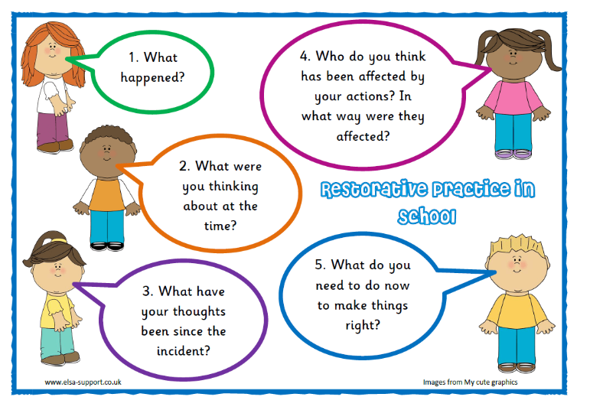

We respect everyone and everything

We listen to the person who is meant to be speaking

We follow instructions first time

We move sensibly, safely and quietly

We keep hands, feet, objects and unkind words to ourselves

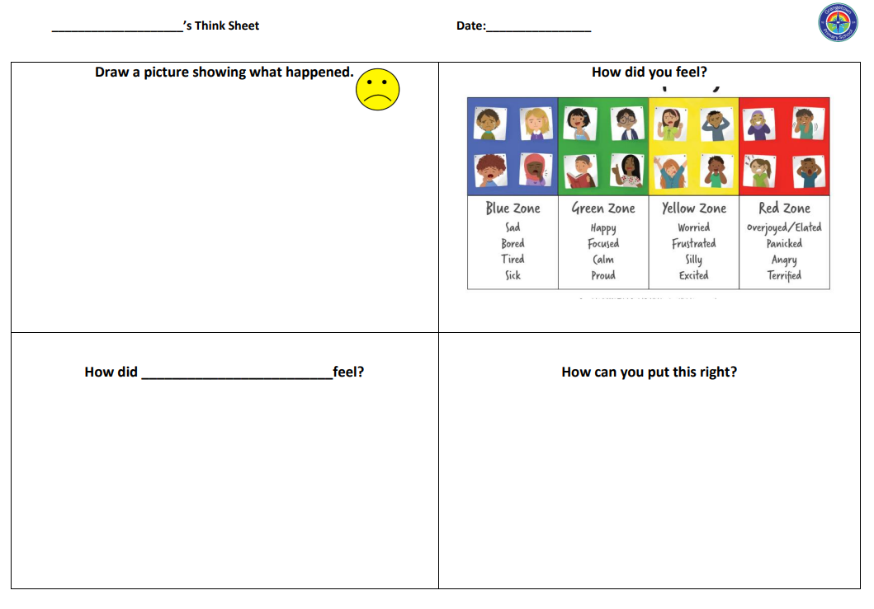
Appendix 3 - Think Sheets

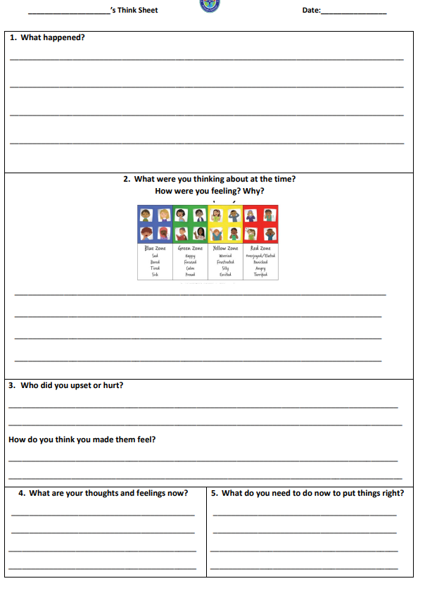

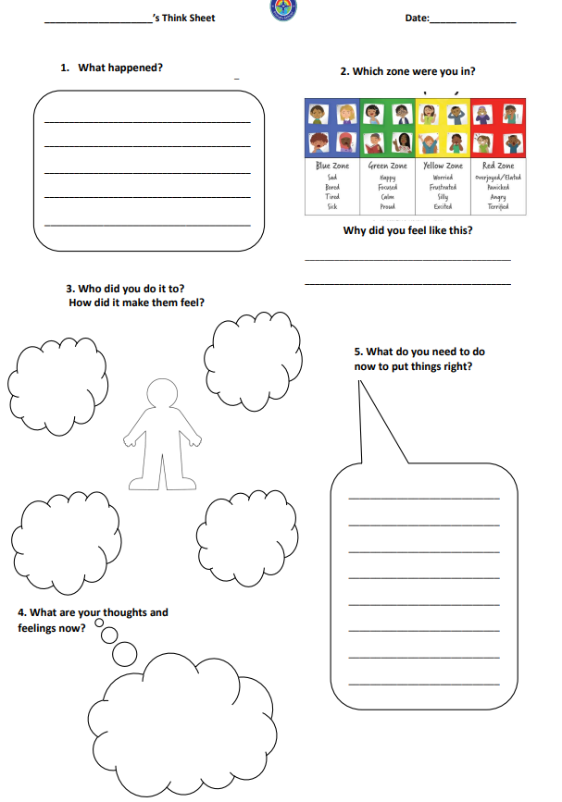

Appendix 4
TRAVEL BEHAVIOUR CODE
Latest edition is here: https://www.gov.wales/sites/default/files/publications/2018-03/all-wales-travel-behaviour-code-statutory-guidance.pdf

Your Safety is very important. You must behave responsibly and safely when travelling to and from school or college, whether you go there by bus, train, taxi, bicycle, walking or any other way. If you get a bus to school or college, you must also follow the rules in the School Bus Travel Behaviour Code.

If you do not follow this Code, for your own safety and other people’s, local authorities, schools and colleges can take action against you. This might involve taking away your right to school transport and even excluding you from school.

Your Responsibility | Your Safety | Your Rights
- Always respect others, including other pupils, drivers and the public.  - Always respect vehicles and property.  - Always be polite.  - Never drop litter.  - Always obey the law. | - Always behave well when travelling.  - Always follow the driver’s instructions when travelling.  - You must not distract drivers.  - Always cross the road safely and sensibly.  - Always travel by a safe route. | - To be safe when travelling.  - To be treated fairly and with respect.  - To tell someone if somebody or something is causing you problems.  - Not to be bullied or picked on.
Please tell a teacher, parent or driver about any bad behaviour or bullying you see.

INCIDENTS INVESTIGATED BY EDUCATION INSTITUTIONS

- Section 89 of the Education and Inspections Act 2006 (as amended by the Measure) places a duty on headteachers to incorporate the Code into the school’s behaviour policy and thus ensure that pupils comply with the Code. It also allows headteachers to take action against pupils who misbehave when they are travelling from home to school, but not on the premises of the school and are not under the lawful control or charge of a member of staff of the school.

- Further guidance on the use of sanctions for behaviour outside the school premises will be contained in the document “Safe and Effective Intervention”. The final guidance will be included as amendments to the Assembly Government’s guidance on behaviour contained in Inclusion and Pupil Support (Circular 47/06).

- Individual schools are best placed to make judgements about what is the most appropriate action to take in particular circumstances dependant on the severity of the misbehaviour. Ultimately, schools may use exclusion on a fixed-term or permanent basis as a sanction but in doing so must comply with the Welsh Assembly Government’s guidance on this.

- Liaison between the school and the local authority is particularly important. Even if the local authority provides transport, the local authority and school may decide that action under the school behaviour policy is more appropriate to the incident. A learner should not generally have sanctions imposed on them for an incident on school transport under both the Travel Behaviour Code and the school’s behaviour policy.

- It is expected that education institutions will investigate all incidents not dealt with by local authorities, under the provisions of their existing behaviour policy.

Pupil Voice Contribution - February 2024


